Complex Activity

After importing the complex project as shared by trainer into the visual studio, create Dockerfile for all three server, client, worker

Compose 1 docker-compose.yml file and paste the code present in the slides

Now go to the console of visual studio and run the commands as below :

1. Go to the ComplexWeb project folder by using **cd** command

1. Now run this command to build the containers

1. Build is composed and our server started running

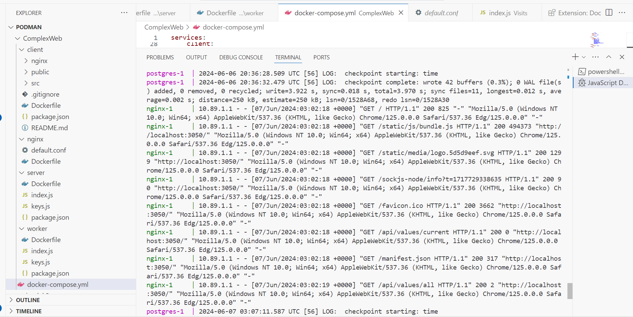

1. Open localhost:3050 in the browser

